Instructions for Data Base Connectivity

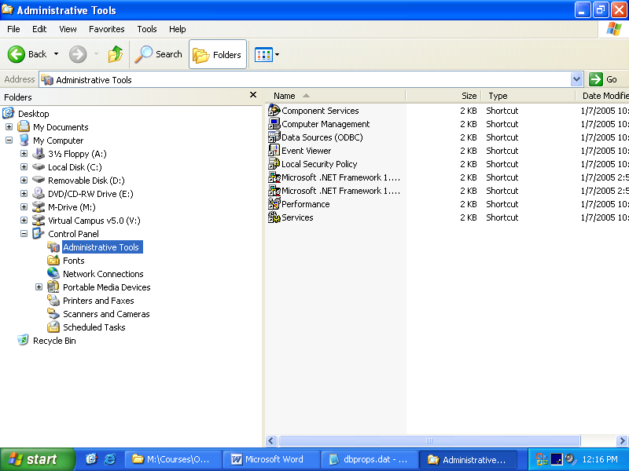

- from control panel click on the folder icon ( to see the two panels)
- select Administrative Tool
- Select Open Data Source ( OOBC)

4. In the User DSN tab (on the top) select MS Access DataBase, and press Add..

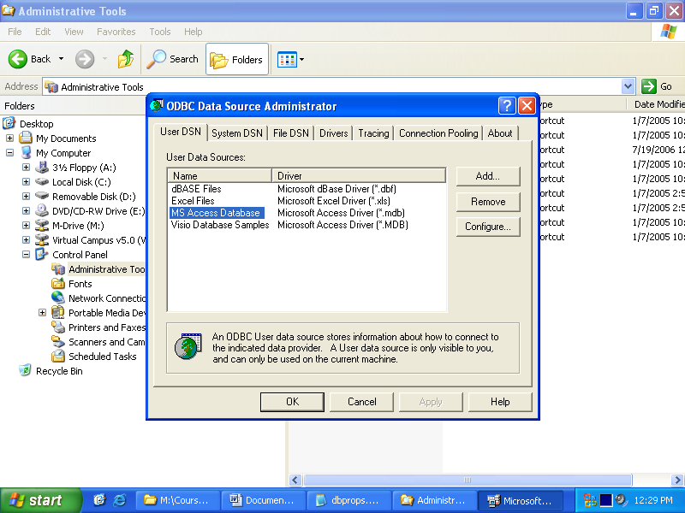

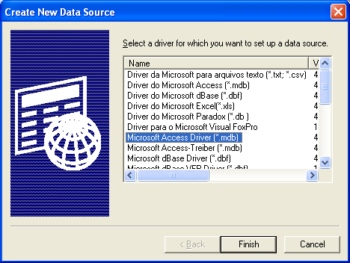

5. Press Finish
6. In The DATA source Name Type: TestDB ( the name of the database)
7. press Select
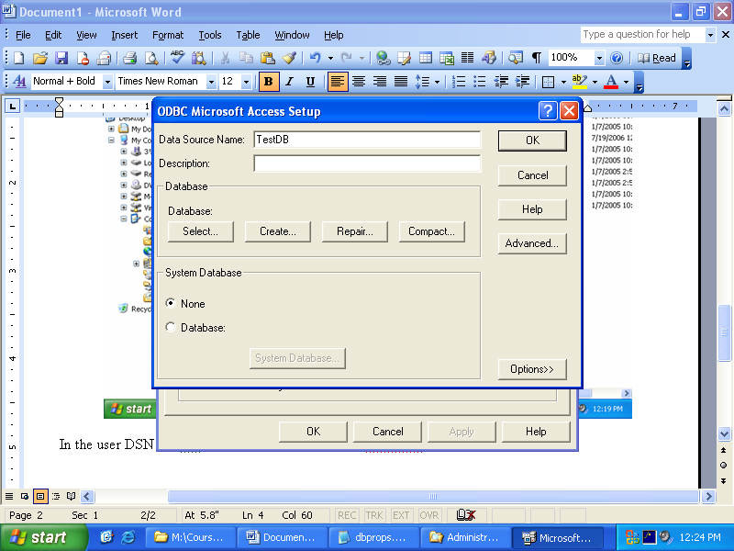

8. Now select the database . If the database is stored on the desktop, go to desktop and select the name of the table like: testDB and press ok

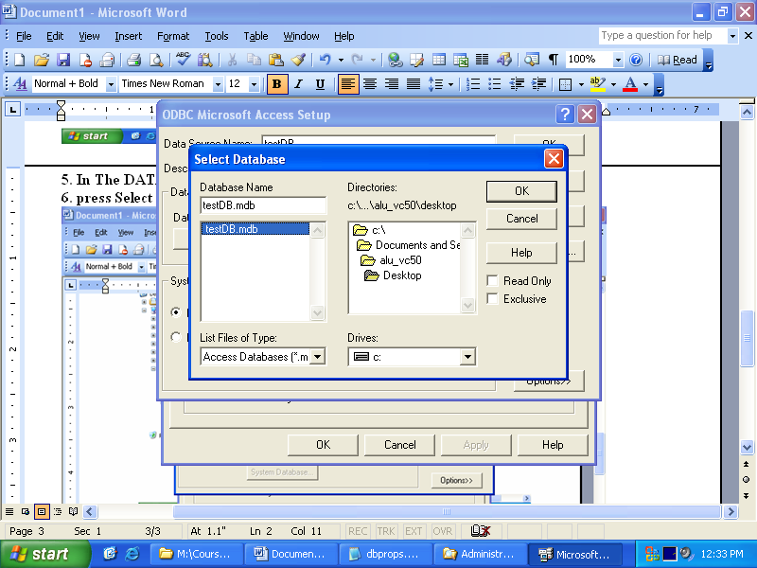

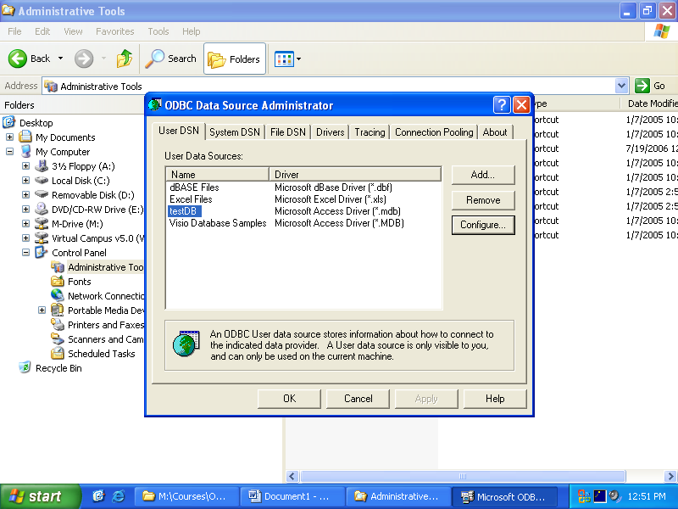

9. Press OK

